response time, execution time vs /throughput/, bandwith > PC vs server

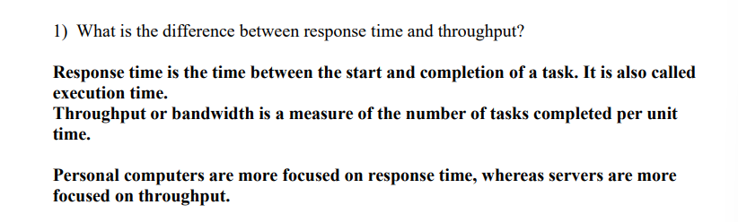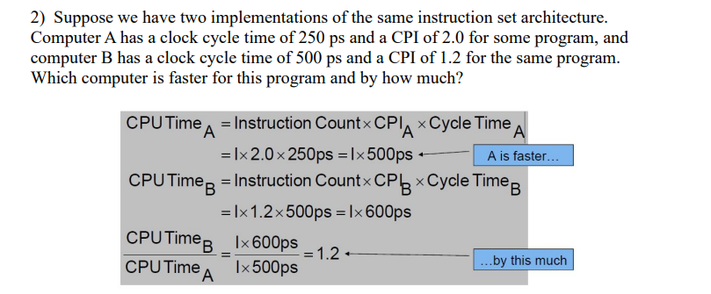

/instruction set architecture/, /clock cycle time(ps)/, /CPI/

> CPU Time = /Instruction Count/ \* CPI \* Cycle Time

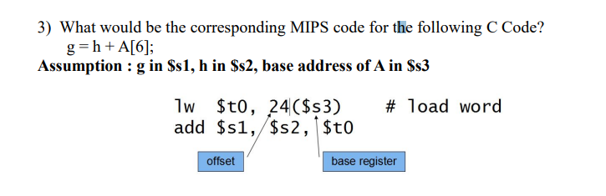

C code vs MIPS code(lw-load word)

